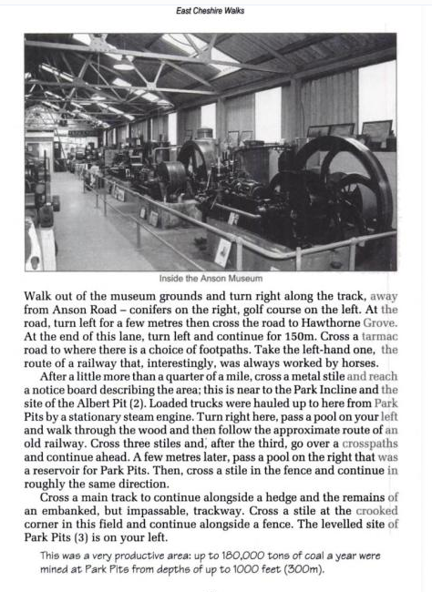
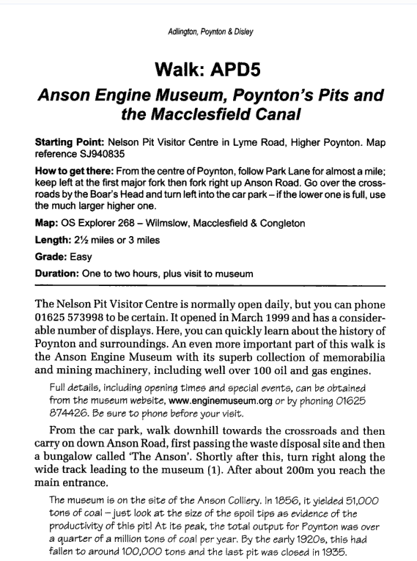
This walk is one of several great local walks in the book “East Cheshire Walks: from Peak to Plain” by Graham Beech. Reproduced by the museum with kind permission of the author. Book available in our gift shop.
