Events and Exhibitions 2014

The museum is currently closed over the winter months and will reopen on Easter Sunday and Monday (20/21 April). It will then be open every Friday, Saturday, Sunday and Bank Holiday until 26 October 2014.

Opening of the 2013 season, Easter Sunday and
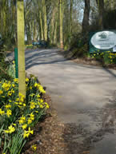
Monday 20th 21st April

The 2014 season gets off to a flying start on Easter Sunday and Monday.

Come along and see the changes that we have been working on over the winter months. A new storage building at the car park helps us keep many of our future restoration projects under cover. In the Gardner room we have completed the installation of 2 more engines showing traditional working environments. Improved displays in the Memorial Building including showing steam boiler ends in the steam area.

A great many of our engines will be running for our 1st weekend of the season (including steam), our Craft Centre will also be operational, view our acclaimed scale model of Poynton c1900 and when you need to sit down snuggle into the cinema seats and view one of our many engine films on offer. To help us raise funds there will be a Tombola in our shop area with a great many prizes for you to try and win.

Over the Easter weekend the Milk Van will be on site to tempt you with bacon butties and mugs of steaming hot tea so do come and join us.

After the Easter opening, the museum will then be open every Friday,
Saturday, Sunday & Bank Holidays.

Demonstrations of old crafts

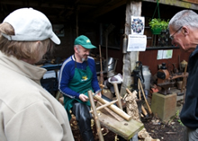
Bodging (the traditional craft of working with greenwood using portable tools including a polelathe to turn chair legs, etc) while another volunteer, will be working at the forge.
There is no additional charge to see the demonstrations, normal museum entry applies. Museum open 10:00 17:00.

Sunday 20th April; Monday 21st April; Monday 5th May; Sunday 25th/ Monday 26th May; 15th June; Wednesday 25th June (museum open 3 – 8pm); Sunday 20th July; Sunday 24th August; Monday – 25th August; Sunday 21st September; Saturday 25th October; Sunday 26th October

Steam engines running
As well as the extensive collection of Internal Combustion engines at the museum that track its development from the earliest engines through to a modern Bentley engine; we have a steam section with some interesting examples of different steam engines.

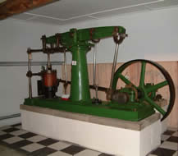
These include a Fowler Beam engine; an A frame Steam engine and a pair of Robey engines. These engines run every month in the season.

There is no additional charge to see the steam engines, normal museum entry applies. Museum open 10:00 17:00.

Sunday 20th April; Monday 21st April; Sunday 25th/ Monday 26th May; 15th June; Wednesday 25th June (museum open 3 – 8pm) ; Sunday 20th July; Sunday 24th August; Monday – 25th August; Sunday 21st September; Saturday 25th October; Sunday 26th October

Gardner Forum AGM 
The museum will once again be hosting the AGM for the Gardner Engine Forum. It is on Saturday 26th April beginning at 2pm.
We look forward to welcoming you to the museum and the AGM.

For more information about the Gardner Engine Forum click here.

Engines at Twilight Open until 20:00 Saturday 17th May


The museum will once again be taking part in this International movemement by opening late. Many engines running with talks on how they work and engine development through the years.

The scale model of Poynton c1900 showing all the collieries of the time will also be available to view.

Normal opening hours 10:00 17:00 then staying open until 20:00.

Largest Steam Engine in Cheshire running Bank Holiday Sun/Monday (25/26 May)

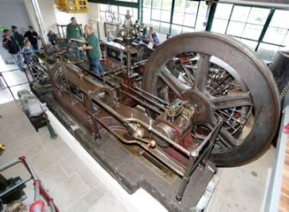
There are few people who are not moved and enthralled by the sight and sound of a giant steam engine in motion. The power and majesty of the spinning flywheel ignites a passion deep inside and makes you wonder about the work and history of these industrial giants.

The Stott mill engine at the museum has been lovingly restored by our volunteers and will run on live steam for the first time this year, over the Bank Holiday Weekend. The 10 foot flywheel is cast in iron and weighs 10 tons on its own.

Although the smaller steam engines at the museum run every month during the season, the Stott engine will only be run on specified dates.

There is no additional charge to see the steam engine, normal museum entry applies. The Craft Centre at the museum will also be in operation. Everyone is invited along – for a great day out.

Museum is open 10:00 17:00 Friday, Saturday, Sunday & Monday
over that weekend.

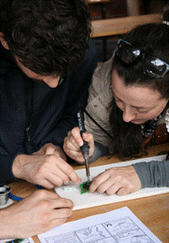
Learn how to solder a flashing LED badge
Saturday 31 May 10am - 1pm

Learn how to solder using a flashing LED badge kit that you can take away and wear proudly as proof of your new status as a soldering virtuoso. (Age 8 and over)

The first 50 participants get to solder their badge for free so do come along early. (Usual price for soldering kit/lesson £3 each.) Normal museum entry applies (children under 12 free)


Amazed By Science is a Cheshire-wide festival focusing on science, technology, engineering and maths, in one of the most science rich areas of the UK. For a full list of activities and venues across Cheshire see http://amazedbyscience.co.uk/

Fathers Day Sunday 15th June

What to give dad for his special day – why not a trip to see engines running and be fascinated by the machinery of yesteryear?

Geoff Challinor, Chairman of the museum on Anson Road, Poynton said “My dad encouraged my interest in engines by giving me one to restore when I was only 14, now with over 250 engines at the museum to play with it is a full time job. This is my opportunity to say “thanks” to dads everywhere by making it a special day here at the museum. We intend to have several of our engines running that day to make it a really special Fathers Day. We have offered this for the past couple of years and it is always popular. Families can treat their dad and make it a really special day out for all the family.”
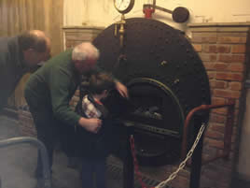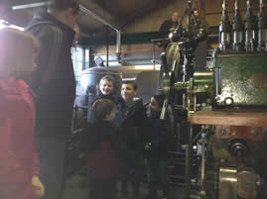

If you want to join Geoff and the volunteers on Fathers Day, pop along between 10:00 17:00 to see the impressive collection of internal combustion and steam engines.

To add to the atmosphere that day many engines will be running; there is also a special Fathers Day Fun Sheet and remember, if you show your dad or granddad around that day he gets in free! The shop has a range of unusual gifts and hand made cards to make all dads and granddads feel extra special.

The museum also has a giant model of Poynton showing how thevillage looked c1900. The volunteers have spent over 5000 hours bringing the miniature village to life. It’s available to view and for those local to the area it is great fun working out where your house is now compared with the landscape of old collieries and railways.

1000 Engine Rally, Chelford 21st /22nd June
The annual rally takes place at Chelford over the weekend, the organisers aim to take the Astle Park Rally forward as Europe's largest display of Vintage engines. Come and join in the fun. For more details see their website
Saturday evening 22nd June museum open until 21:30 for annual visit.


Midsummer Mingle – calling all engine men - Wednesday 25th June

Celebrate Midsummer and mingle with old engineering colleagues.
Everyone is invited along particularly anyone who has worked in the engineering/engine manufacturing companies in the area, this will make it a reunion as well as a great day out.

Museum open 15:00 until 20:00. but most people will arrive for the barbeque around 18:00. Normal museum entry applies but includes a tasty Norbury Farm hotdog.

Higher Poynton Summerfest 13th July

Formally known as the Middlewood Way Open Day, the Higher Poynton Summerfest will be held on 13th July 2014 from 11.30am to 4.30pm.
Family friendly entertainment including live music and dancing, dog training show, bird of prey displays, climbing wall, show jumping, face painting, bouncy tunnel and many local produce and craft stalls. Childrens entertainer from 1.00pm to 4.30pm with magic, puppets and balloon sculpture. Free entry. Click for more details.

The museum will have a stall at the fair as always, do pop along and see us.

Poynton Show, Poynton Park Saturday 23rd August
A great day out for all the family. Our volunteers will be supporting this show with and engine, stall and presenting the Les Cawley Memorial Trophy. See the show's website for more details.

Largest Steam Engine in Cheshire running Bank Holiday Sun/Monday (24/25 August)

There are few people who are not moved and enthralled by the sight and sound of a giant steam engine in motion. The power and majesty of the spinning flywheel ignites a passion deep inside and makes you wonder about the work and history of
these industrial giants.

The Stott mill engine at the museum has been lovingly restored by our volunteers and will run on live steam for the first time this year, over the Bank Holiday Weekend. The 10 foot flywheel is cast in iron and weighs 10 tons on its own.

Although the smaller steam engines at the museum run every month during the season, the Stott engine will only be run on specified dates.

There is no additional charge to see the steam engine, normal museum entry applies. The Craft Centre at the museum will also be in operation. Everyone is invited along – for a great day out.

Museum is open 10:00 17:00 Friday, Saturday, Sunday & Monday over that weekend.
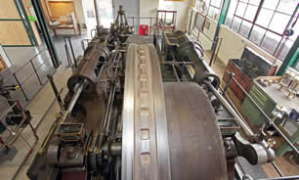

Poynton Festival of Music Sat/Sunday 27th / 28th September

This new community festival will feature both local and visiting acts of all shapes, sizes and genres, “Springboard Poynton” truly is looking to be a melting pot of tastes and culture. See the show's website for details of some of the great concerts taking place over the weekend.
At the museum we have a really exciting opportunity for our visitors to enjoy the museum exhibits and participate in the festival too on the afternoon of Saturday 27th when "Harp & a Monkey" will be playing. There is no additional fee to hear the music, normal museum entry applies.
Harp and a monkey




25 years ago - 1st open weekend at museum 25th/26th October

This closing weekend (25/26 October) will be 25 years since our very first open event. A lot has happened over the years and we now have over 10 times the covered display area than we had back then. There will be a lot happening that weekend with many engines running, a slide show showing how the museum was built and looked all those years ago, craft demonstrations, steam engines running, fun Tombola with lots prizes. Do come along and join us, the museum is open 10 - 5 both days but don't forget the clocks go back that weekend.

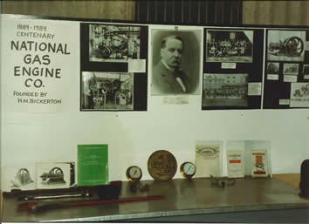
For that first open weekend we had a small exhibition to mark the 100 years centenary of the National Gas Engine Co here are a few photos from that original exhibition. 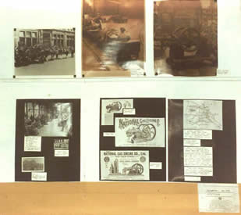

Warped Views - Distant Times Art Exhibition until 26th October

The photographer and exhibition creator Simon Brown says:-
We're really pleased with the amazing new home we have for the Warped Views, Distant Times exhibition for the next few weeks, in the entrance to the Steam Hall at the Anson Engine Museum. The Steam Hall contains the huge Stott Steam Engine... which was used as the backdrop for some of the most iconic shots in the exhibition. We also used a number of other locations there including the working blacksmiths forge.
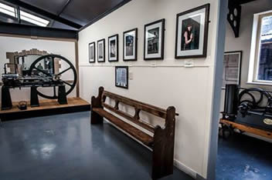
Any Steampunks coming to the museum in costume will receive 1/2 price entry during the exhibition.
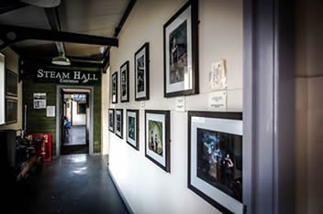
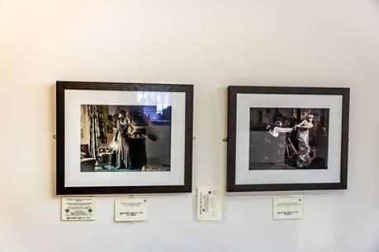

“Turn the Clocks Back” closing weekend 25th / 26th October

Over the weekend a great many of our engines will be running, including the small steam engines. The Craft Centre will be in full swing with demonstrations by blacksmiths at the forge and wood turners/bodging at their lathes. The giant model of Poynton is a treat so do make time to drop into the local history area and talk to the volunteers who have built it. A giant Tombola could send you home with your arms full of presents.

Giant Model of Poynton c1900 Weekends


Our volunteers have been adding yet further detail to the model showing the village as it looked c1900 with the many coal pits and railway lines that covered the land at the time. The detail is fantastic, come along and talk to the volunteers who have lovingly created it.

